**Prac 4: Storing and retrieving data using IPFS**

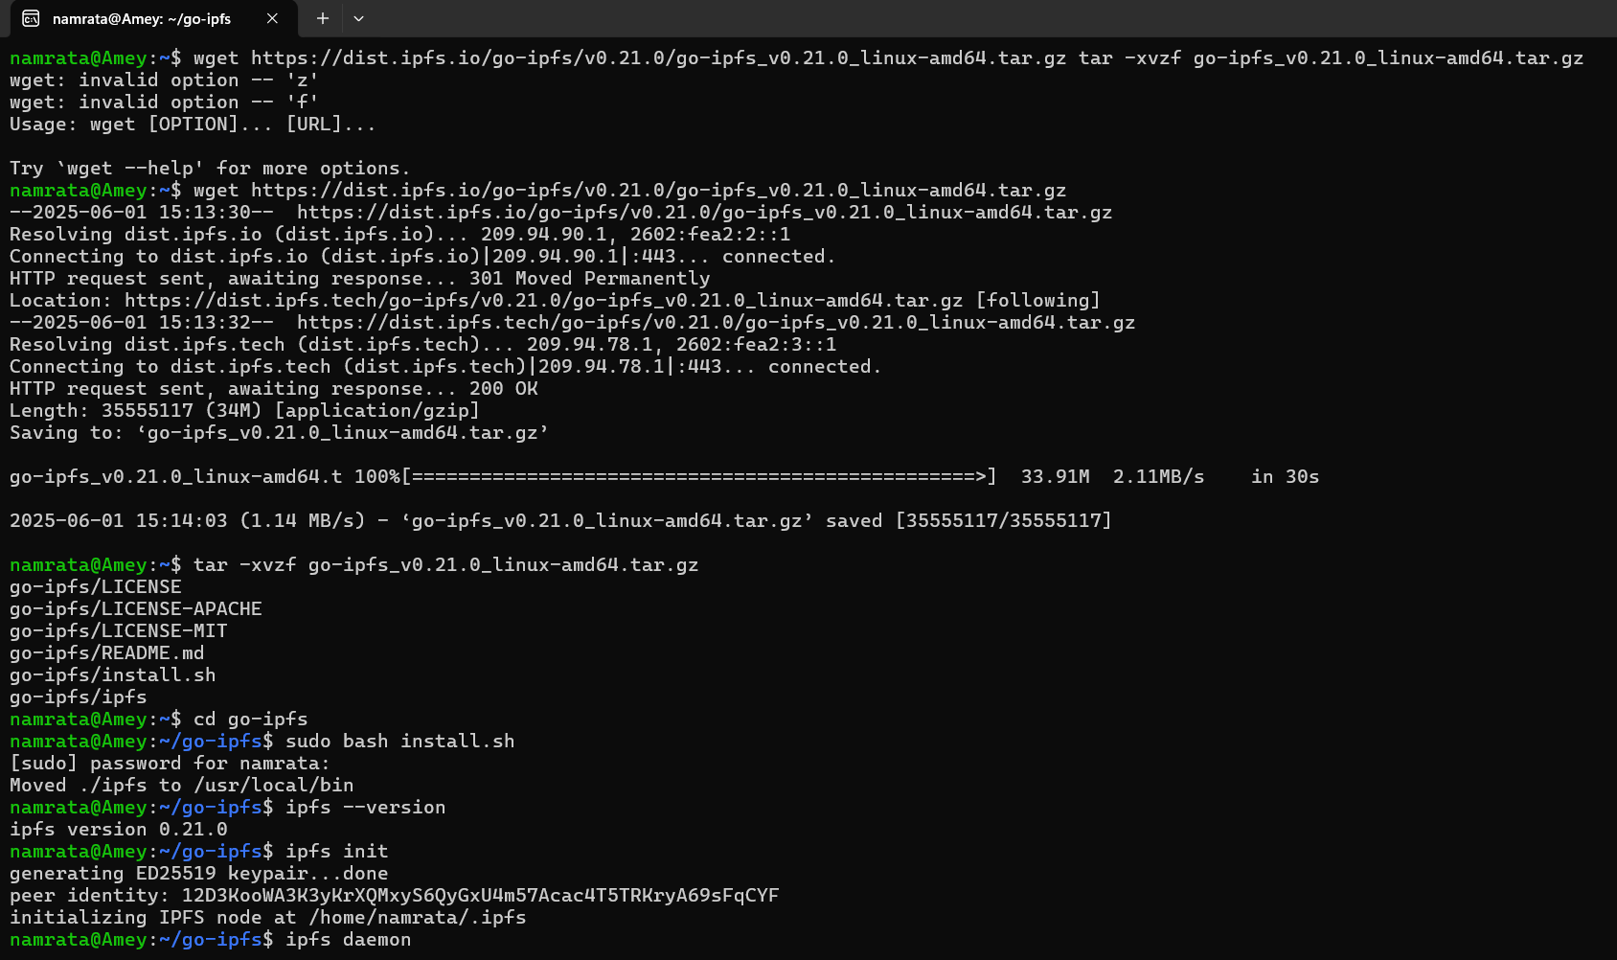

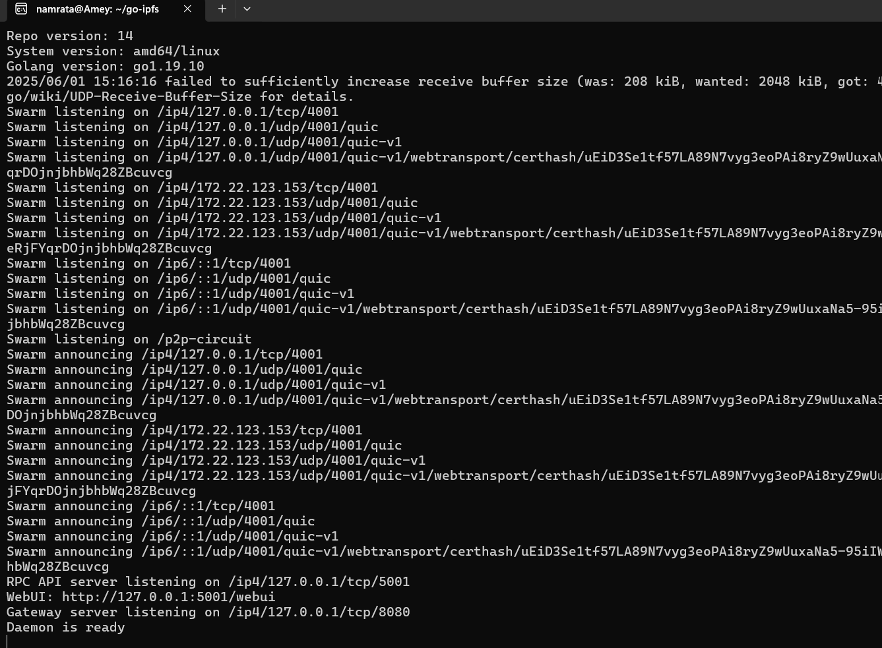

# For Linux/macOS

wget https://dist.ipfs.io/go-ipfs/v0.21.0/go-ipfs_v0.21.0_linux-amd64.tar.gz

tar -xvzf go-ipfs_v0.21.0_linux-amd64.tar.gz

cd go-ipfs

sudo bash install.sh

# Verify installation

ipfs –version

ipfs init

ipfs daemon

**create file in go-ipfs folder**

echo "This is an example file to store on IPFS." > example.txt

ipfs add example.txt

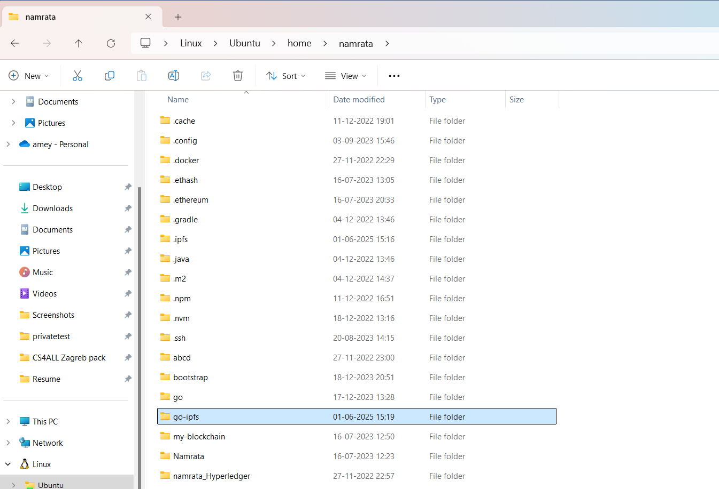

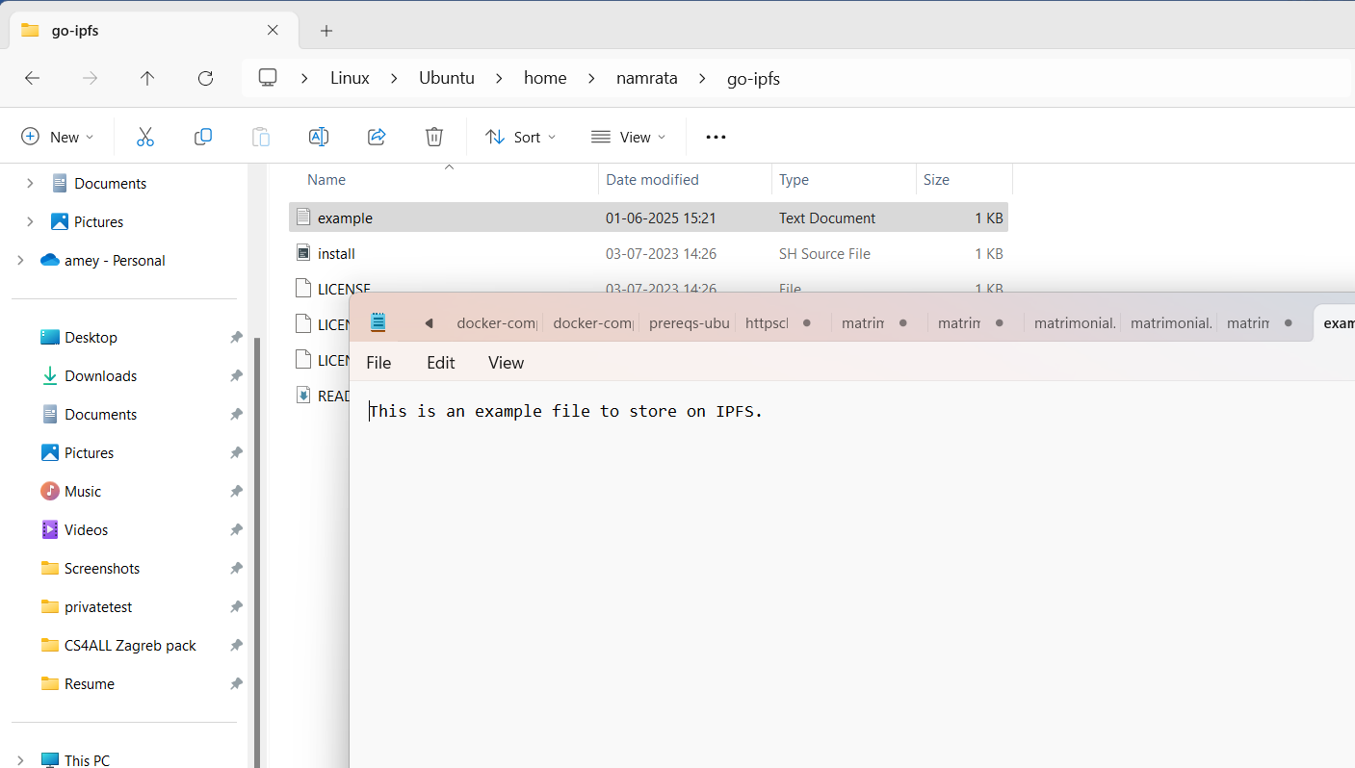

Open new Ubuntu Window

